**How To Install OpenSSL on Windows**

Written by [Rahul](https://tecadmin.net/author/myadmin/), Updated on September 7, 2019

[Windows Tutorials](https://tecadmin.net/category/windows-tutorials/) [Openssl](https://tecadmin.net/tag/openssl/), [windows](https://tecadmin.net/tag/windows/)

OpenSSL is a full-featured toolkit for the Transport Layer Security (TLS) and Secure Sockets Layer (SSL) protocols. It is licensed under an Apache-style license. This tutorial will help you to install OpenSSL on Windows operating systems.

**Step 1 – Download OpenSSL Binary**

Download the latest OpenSSL windows installer from Official download page. The official download page link is given below:

[http://slproweb.com/products/Win32OpenSSL.html](https://slproweb.com/products/Win32OpenSSL.html)

[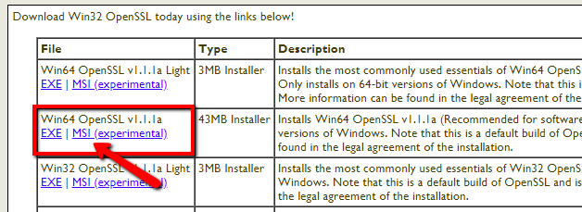](https://tecadmin.net/wp-content/uploads/2018/12/openssl-windows-download.png)

**Step 2 – Run OpenSSL Installer**

Now run the OpenSSL installer on your system. The OpenSSL required Microsoft Visual C++ to be installed on your system. If your system doesn’t have Microsoft Visual C++ installed, the installer will show your message like:

[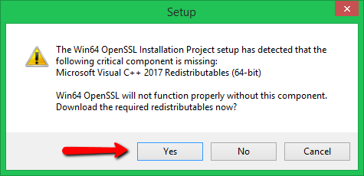](https://tecadmin.net/wp-content/uploads/2018/12/openssl-windows-install-1.png)

Click **Yes** to download and install required Microsoft Visual C++ package on your system.

[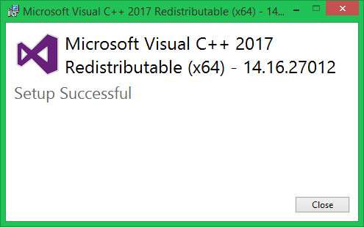](https://tecadmin.net/wp-content/uploads/2018/12/openssl-windows-requirements.png)

Then again run the OpenSSL installer and follow the wizard.

[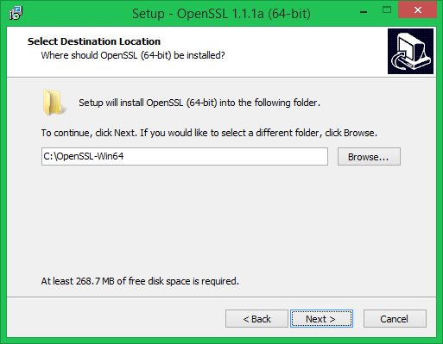](https://tecadmin.net/wp-content/uploads/2018/12/openssl-windows-install-2.png)

**Step 3 – Setup Environment Variables**

Now set the environment variables to function OpenSSL properly on your system. You are required to set OPENSSL_CONF and Path environment variables.

set OPENSSL_CONF=C:\OpenSSL-Win32\bin\openssl.cfg

set Path=......Other Values here......;C:\OpenSSL-Win32\bin

**Set OPENSSL_CONF Variable:**  
[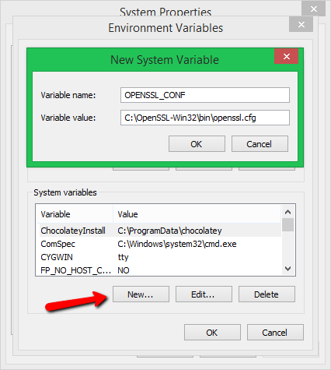](https://tecadmin.net/wp-content/uploads/2018/12/openssl-windows-environment1.png)

**Set Path Variable:**  
[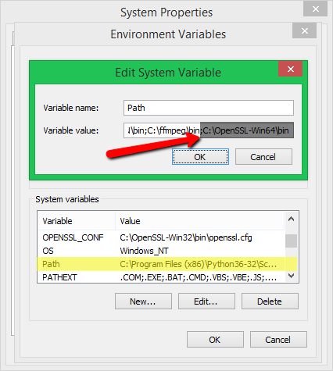](https://tecadmin.net/wp-content/uploads/2018/12/openssl-windows-environment2.png)

**Step 4 – Run OpenSSL Binary**

Open a command prompt and type **openssl** to get OpenSSL prompt. Then run version command on OpenSSL proper to view installed OpenSSL version.

[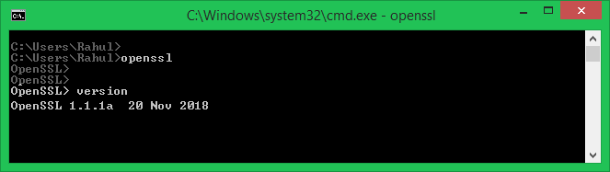](https://tecadmin.net/wp-content/uploads/2018/12/openssl-windows-version.png)

Cmd

openssl req -new -x509 -keyout server.pem -out server.pem -days 365 -nodes